# User Guide

## Splash Screen

The window that is encountered first when the application opens, used to select or import data and consists of the following parts:

1. Import New Video: Allows a user to import a video that is then processed by the model, the result is then possibly sent to the main window to be displayed.
2. Import Processed video: Allows the user to import a compressed file that contains the video named video.mp4 and data named output.csv that is then sent to the main window to be displayed.
3. Select Existing Data: Loads the selected data into the main window that has been imported into the window either by processing or loading pre-processed in the past.

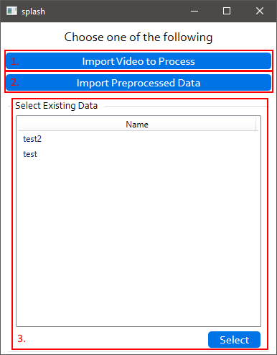

## Main Window

The window that is used to display results from the model alongside the video that is processed to give context, consists of the following parts:

1. Selection Controls: Lets the user select between previously imported or processed video using the Load button and import a new video to be processed using the Upload button.
2. Media: The video that the data represents.
3. Media Controls: Only shown when mousing over the video, allows the user to pause/play the video, see in numerical the progress of the video and control the position of the video using a slider.
4. Summariser: Shows what the model thought was happening at specific positions of the video with a slider being used to see and control the position of the video relative to the data. The colour represents the confidence of the model.
5. Summariser Key: shows what the colours represent in percentage.

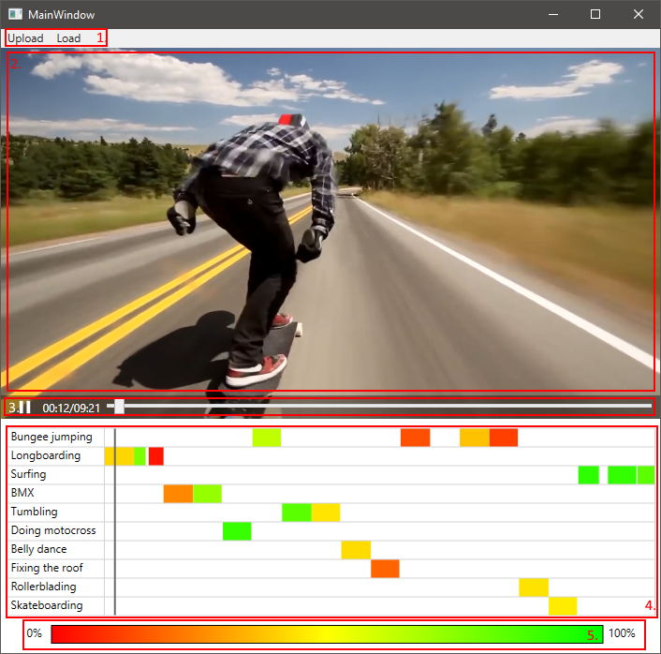

## Load Window

A window that can be used to select previously loaded data or import pre-processed data into the model, consists of the following components:

1. Data selector: Lets the user select a previously loaded data point by its name, the points can be right clicked on to be removed or loaded into the model using the load button.
2. Cancel Button: quits the menu and goes back to the main window.
3. Import Button: Lets the user import previously processed data and then displays it on the main window.
4. Load Button: loads the currently selected data point in the data selector.

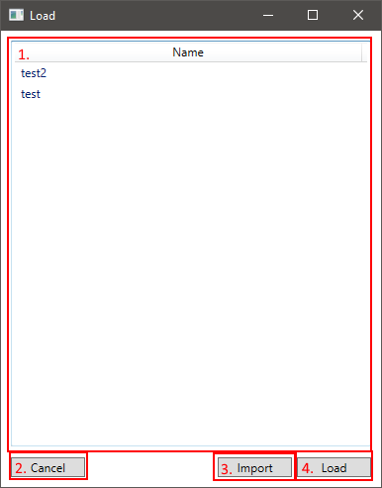

## Upload Window